**Core Java Assignment 1**

1. Explain any five features of Java language.

Ans :

1. **Object Oriented :** Java is a true object-oriented language. Almost everything in java is an object. All program code and data reside within objects and classes. Java comes with an extensive setoff classes, arranged in packages that we can use in our programs by inheritance. The object model in Java is simple and easy to extend.
2. **Multithread and Interactive :** Multithread means handling multiple tasks simultaneously. Java supports multithreaded programs. This means that we need not wait for the application to finish one task before beginning another.
3. **High Performance :** Java Performance is impressive for an interpreted language, mainly due to the use of intermediate bytecode. According to Sun, java speed is comparable to the native C/C++, Java architecture is also designed to reduce overheads during runtime.
4. **Dynamic and Extensible :** Java is a dynamic language. Java is capable of dynamically linking in new class libraries, methods, and objects. Java can also determine the type of class through a query, making it possible to either dynamically link or abort the program, depending on the response.
5. **Robust and Secure :** Java is a robust language. It provides many safeguards to ensure reliable code. It hase compile time and run time checking for data types. It is designed as a garbage-collected language relieving the programmers virtually all memory management problems. Java also incorporates the concept of exception handling which captures series errors and eliminates any risk of crashing the system.
6. Write a note on Garbage collection in Java.

Ans : Java garbage collection is the process by which Java programs perform automatic memory management. Java programs compile to bytecode that can be run on a Java Virtual Machine, or JVM for short. When Java programs run on the JVM, objects are created on the heap, which is a portion of memory dedicated to the program. Eventually, some objects will no longer be needed. The garbage collector finds these unused objects and deletes them to free up memory.

Java garbage collection is an automatic process. The programmer does not need to explicitly mark objects to be deleted. The garbage collection implementation lives in the JVM. Each JVM can implement garbage collection however it pleases; the only requirement is that it meets the JVM specification. Although there are many JVMs, Oracle’s HotSpot is by far the most common. It offers a robust and mature set of garbage collection options.

1. Write a program to show the use of abstract class.

Ans : In this example, Bike is an abstract class that contains only one abstract method run. Its implementation is provided by the Honda class.

abstract class Bike{

  abstract void run();

}

class Honda extends Bike{

    void run(){System.out.println("running safely");

    }

    public static void main(String args[]){

        Bike obj = new Honda();

        obj.run();

}

}

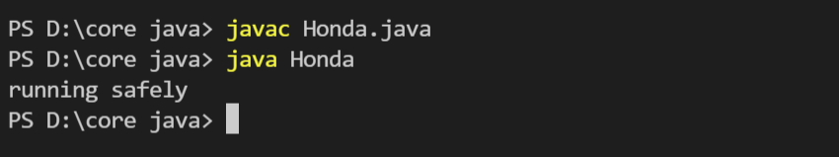

1. Why Java is called as platform independent language?

Ans : Java is a platform-independent language. In other words, we can write our code once and then run it anywhere, on any platform that provides the environment to run it. This environment is the Java Virtual Machine (JVM). The JVM should be present to execute the code. The JVM is different for each platform. In the case of Java, platform independence does not mean that we can run the code anywhere, we can run it wherever the environment is provided. This is the key point of platform independence in Java. We can define a platform as the sum of hardware and software, that provides the environment to run the program. We can realistically say that a platform is the computer and the operating system running on it. The operating system can be Windows, Mac, Linux, or any of many others. To run a program on any machine you need to convert it to the machine language so that the specific machine can understand it. In Java the source code is not directly converted into the machine code. It is first converted into the byte code of the JVM. Using the Java Virtual Machine we can make the byte code understandable to any platform. That is why the byte code is known as platform-independent. But on the other hand the Java Virtual Machine is different for each platform; that is why it is known as platform-dependent. Java is platform-independent because it does not depend on any type of platform. Hence, Java is platform-independent language.

1. Explain Java program structure.

Ans :

class Hello

{

    public static void main(String[] args)

    {

        System.out.println("Hello Java");

    }

}

Class declaration : class Hello declares a class which is an object-oriented construct. Java is true true object-oriented language therefore, everything must be placed inside a class.

Opening Braces : Every class definition in Java begins with an opening braces “{” and ends with a matching closing braces “}”

The main line : public static void main(String args[]) defines a main method. Every java application program must include main() method. This is the starting point for the interoreter to begin the execution of the program. A java application can have any number of classes but only one of them must include a main method to initiate the execution.

Public : The keyword publics is an access specifier that declares the main method as unprotected and therefore making it accessible to all other classes.

Static : The keyword static which declares this method as one that belongs to the entire class and not a part of any objects of the class.

Void : The type modifier void states that the main method does not return any value.

The output line : The println method is member of the out object which is static data member of System class. The method println always appends a newline character to the end of the string.

1. What are command line arguments? Explain with example.

Ans : The command line argument is the argument that passed to a program during runtime. It is the way to pass argument to the main method in Java. These arguments store into the String type args parameter which is main method parameter.

class practical1a{

    public static void main(String args[]){

        float length, breadth, perimeter, area;

        length = Float.parseFloat(args[0]);

        breadth = Float.parseFloat(args[1]);

        perimeter = 2 * (length + breadth);

        System.out.println("Perimeter of rectangle : "+perimeter);

        area = length * breadth;

        System.out.println("Area of rectangle : "+area);

    }

}

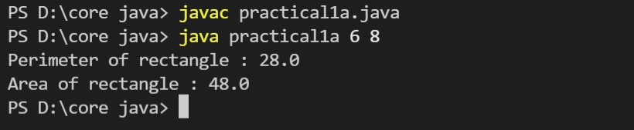

1. Explain various data types available in Java.

Ans : In java, data types are are classified into two categories

1. **Primitive data type**
2. **Boolean :** The Boolean data type is used to store only two possible values: true and false.
3. **Byte :** t isan 8-bit signed two's complement integer. Its value-range lies between -128 to 127 (inclusive). Its minimum value is -128 and maximum value is 127. Its default value is 0.
4. **Short :** The short data type is a 16-bit signed two's complement integer. Its value-range lies between -32,768 to 32,767 (inclusive). Its minimum value is -32,768 and maximum value is 32,767. Its default value is 0.
5. **Int :** The int data type is a 32-bit signed two's complement integer. Its default value is 0.The int data type is generally used as a default data type for integral values unless if there is no problem about memory.
6. **Float :** It is used to Stores fractional numbers.
7. **Non primitive data type :** Non-primitive data types are used to store a group of values.
8. **String :** A string represents a sequence of characters like India, ABC123, etc. The simplest way to create a string object is by storing sequence of characters into string type variable
9. **Array:** An array in java is an object which is used to store multiple variables of the same type. These variables can be primitive or non-primitive data types.
10. Explain if else statement with example in Java.

Ans :

If : It is used  to specify a block of code to be executed, if a specified condition is true.

Else : It is used  to specify a block of code to be executed, if a specified condition is false.

class Condition {

  public static void main(String[] args) {

    int number = 20;

    if (number < 18) {

      System.out.println("Number is less than 20");

    } else {

      System.out.println("Number is greater than 20");

    }

  }

}

In the above example number 20 is greater than 18 , so the condition is false. Because of this, we move on to the else condition and print to the screen Number is greater than 18.

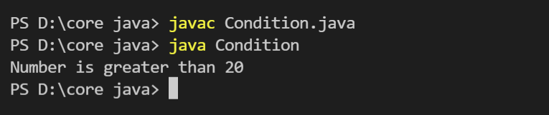

1. Compare While, Do while and for loop in Java.

Ans :

|  |  |  |  |
| --- | --- | --- | --- |
| Comparision | While | Do while | For |
| **Introduction** | The Java while loop is a control flow statement that executes a part of the programs repeatedly on the basis of given boolean condition. | The Java do while loop is a control flow statement that executes a part of the programs at least once and the further execution depends upon the given boolean condition. | The Java for loop is a control flow statement that iterates a part of the programs multiple times. |
| **Syntax** | while(condition){ //code to be executed } | do{ //code to be executed }while(condition); | for(init;condition;incr/decr){ // code to be executed } |
| **When to use** | If the number of iteration is not fixed, it is recommended to use while loop. | If the number of iteration is not fixed and you must have to execute the loop at least once, it is recommended to use the do-while loop. | If the number of iteration is fixed, it is recommended to use for loop. |
| **Example** | //while loop int i=1; while(i<=10){ System.out.println(i); i++; } | //do-while loop int i=1; do{ System.out.println(i); i++; }while(i<=10); | //for loop for(int i=1;i<=10;i++){ System.out.println(i); } |

1. What is constructor in Java? Write a program to demonstrate its use.

Ans : In Java, a constructor is a block of codes similar to the method. It is called when an instance of the class is created. At the time of calling constructor, memory for the object is allocated in the memory. It is a special type of method which is used to initialize the object. Every time an object is created using the new() keyword, at least one constructor is called. It calls a default constructor if there is no constructor available in the class. In such case, Java compiler provides a default constructor by default.

import java.io.*;

class Student{

    String name;

    int rollno;

    int marks;

    BufferedReader br = new BufferedReader(new InputStreamReader(System.in));

    Student(){

        try{

            System.out.println("Enter the Rollno");

            rollno = Integer.parseInt(br.readLine());

            System.out.println("Enter the Name");

            name = br.readLine();

            System.out.println("Enter the Marks");

            marks = Integer.parseInt(br.readLine());

        }

        catch(Exception e){

            System.out.println(e);

        }

    }

        void show()

        {

            System.out.println("Rollno is : "+rollno);

            System.out.println("Name is : "+name);

            System.out.println("Marks is : "+marks);

        }

    }

    class Stdinfo{

        public static void main(String args[]){

            Student s1 = new Student();

            s1.show();

        }

}

